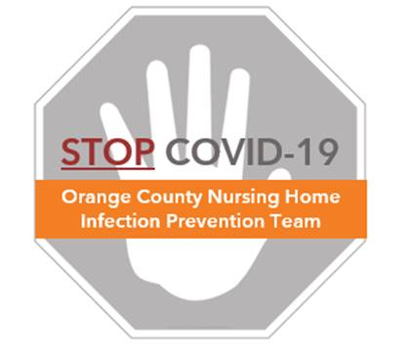

**Preventing COVID-19 in Nursing Homes**

**Protocol – Folding Cleaning Cloths**

**It is important to properly fold a cleaning cloth. This will make 8 clean sides from a single cloth.**

1. **Lay cleaning cloth flat**
2. **Fold cloth in half vertically**
3. **Fold cloth in half again, horizontally**

