

**Preventing COVID-19 in Nursing Homes**

**Protocol – Saturating Cleaning Cloths**

1. **Fold cleaning cloths in half vertically, and stack on top of each other in the same direction.**
2. **Place folded stack of cleaning cloths upright into bin.**

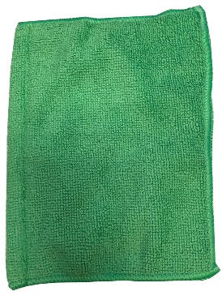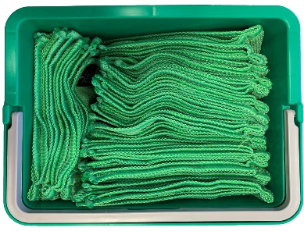

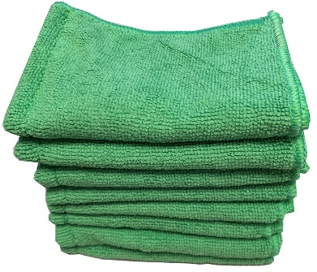

1. **Fill bin with disinfectant to saturate the cleaning cloths**
2. **Ensure cloths are completely wet, but not dripping from over-saturation before cleaning**



