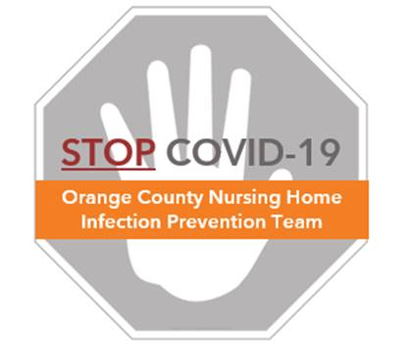

**Preventing COVID-19 in Nursing Homes**

**Protocol – UV Marking**

**UV Marking**

* UV marking is an effective way to measure housekeeping compliance
* UV markers are a gel that can be seen only under a UV flashlight. UV markers are placed on surfaces that are meant to be cleaned. If an object is successfully cleaned, the mark will no longer be visible.
* UV marking is helpful because it provides immediate performance feedback, is relatively inexpensive, and is a fair measurement
  + On most flat surfaces, UV marks are removed reasonably with fully-saturated cleaning cloths and wiping

**High-touch Surfaces**

* High-touch surfaces in nursing homes that may be UV marked include, but are not limited to:
  + Resident Room
    - Headboard and Footboard
    - Call Button/TV/Bed Remote
    - Nightstand
    - Over Bed Table
    - Bathroom Handrail
    - Light Switches and Door Handles
  + Common Areas
    - Nursing Station Countertops and Handrails
    - Med Cart Handrails
    - Patient Lifts
    - Dining Room Tables and Chairs
    - Restorative Nursing Walkers
    - Weigh Scale Machines
    - Rehab Room Equipment
    - Shower Handrails and Chairs

**Applying UV Marks**

* Using the fluorescent gel of choice, apply a UV marker on a surface
  + The mark should be a thin layer. If too much gel is applied, it may be harder for housekeepers to clean it.
  + Be fair about where you mark. Only mark areas that are expected to be cleaned by housekeeping staff.
  + Use a UV flash light (shown below) to see that the mark has been placed on the surface
* Randomly select surfaces to mark so housekeepers do not become focused on cleaning some objects while avoiding others

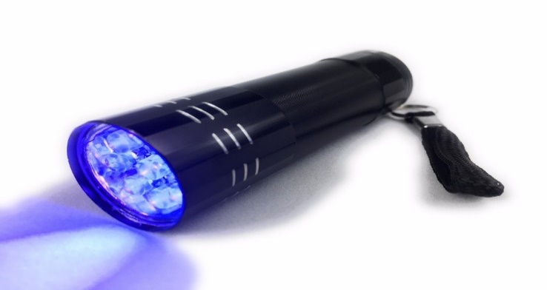

**Observing Marking Results**

* After a full cleaning cycle, use a UV flash light to view the UV mark
* Use the following chart to compare results, and record results on the “UV Marking Log”

|  |  |  |
| --- | --- | --- |
| **Not Cleaned** | **Partially Cleaned** | **Fully Cleaned** |
| Example:  C:\Users\cberman1\AppData\Local\Microsoft\Windows\Temporary Internet Files\Content.Outlook\VCYGAT4O\NotCleanTable.jpg | Example:  C:\Users\cberman1\AppData\Local\Microsoft\Windows\Temporary Internet Files\Content.Outlook\VCYGAT4O\PartiallyCleanTable.jpg | Example:  C:\Users\cberman1\AppData\Local\Microsoft\Windows\Temporary Internet Files\Content.Outlook\VCYGAT4O\CleanTable.jpg |

**Provide Feedback**

* Use the results of UV marking to provide feedback to your housekeeping staff
* This easy and fair visual assessment allows housekeepers to quickly see what areas need improvement